

15610 Wright Bros. Dr. Addison, TX 75001 USA
Phone: 972-661-1166 Fax: 972-661-1144
www.sportchutes.com

“World’s leading authority on unique water toys”

SPORT CHUTES BODY HARNESS SPECIFICATIONS

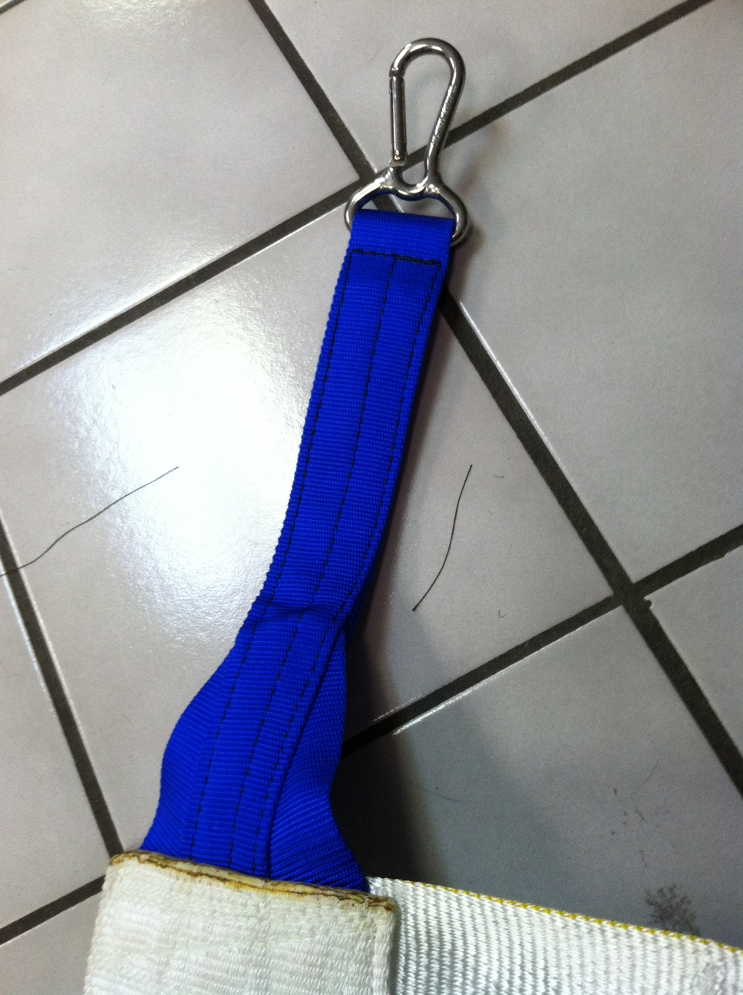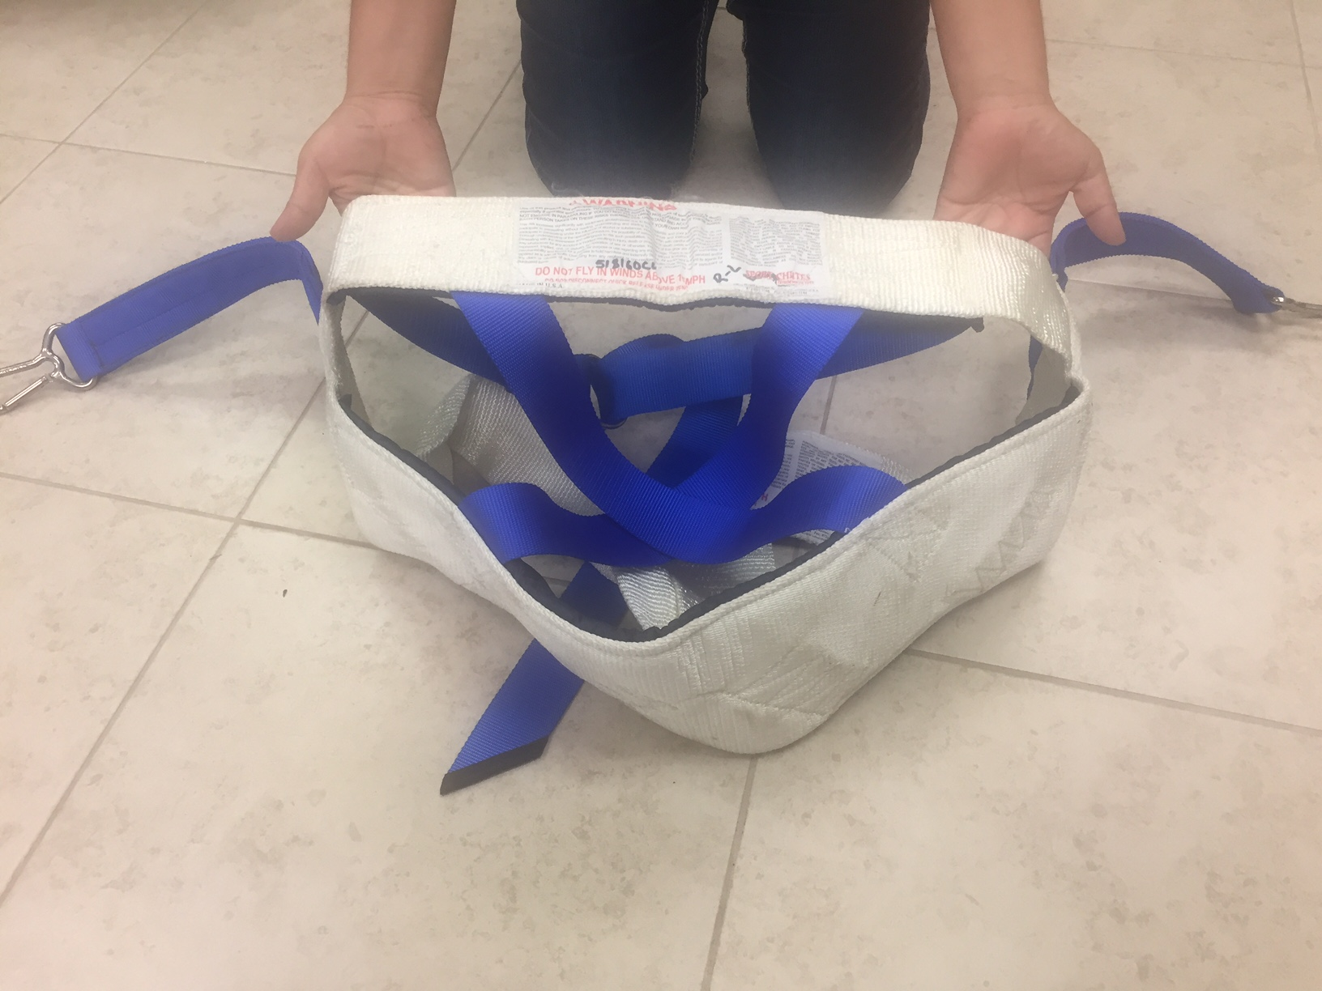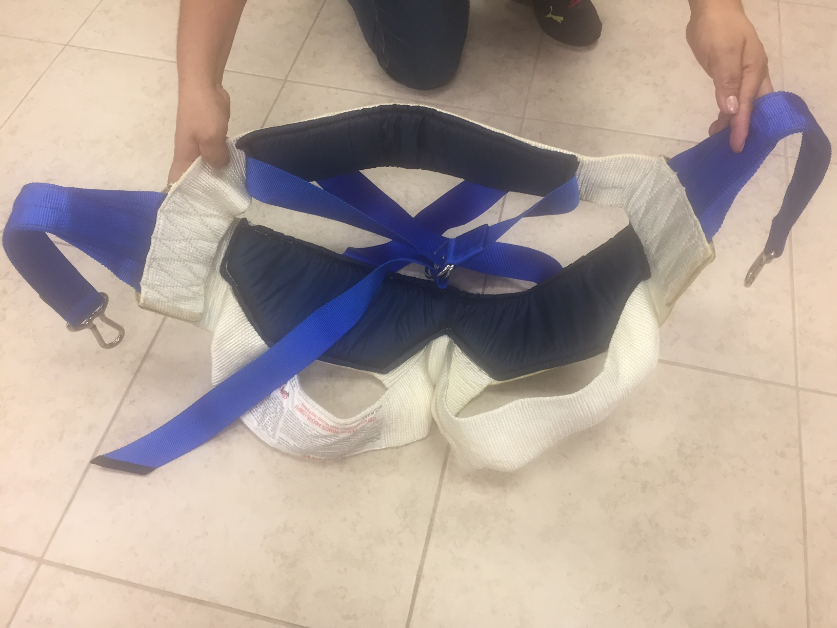
---2” NYLON webbing for straps and belt; straps three layers, each 7000 lb. test break strength
---4” NYLON sling webbing for back strap and leg loops, 60,000 lb. test break strength
---6” NYLON sling webbing for seat, 100,000 lb. test break strength
---2” STAINLESS STEEL “D” rings for belt, 1500 lb. test break strength each
---2” SPRING CLIPS 2200 lb. test each
---Each clip has Nylon seat belt webbing (6500 lb. test) buffer webbing internally to prevent wear and chafing
---Closed cell foam seat and back strap padding for comfort

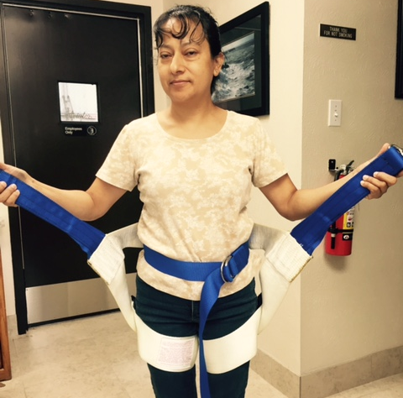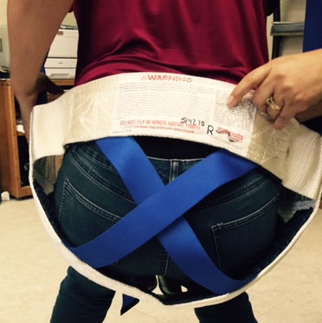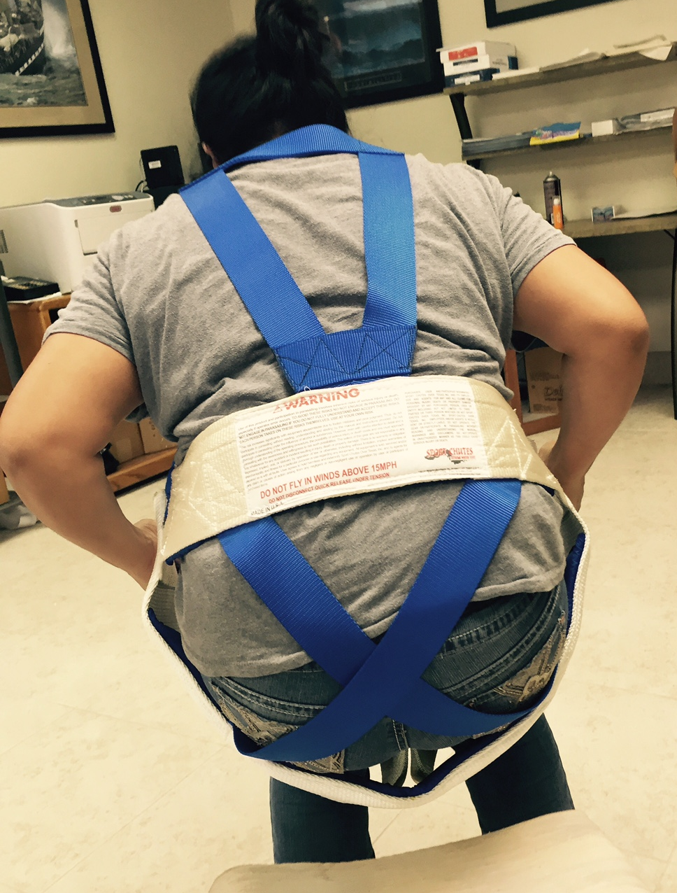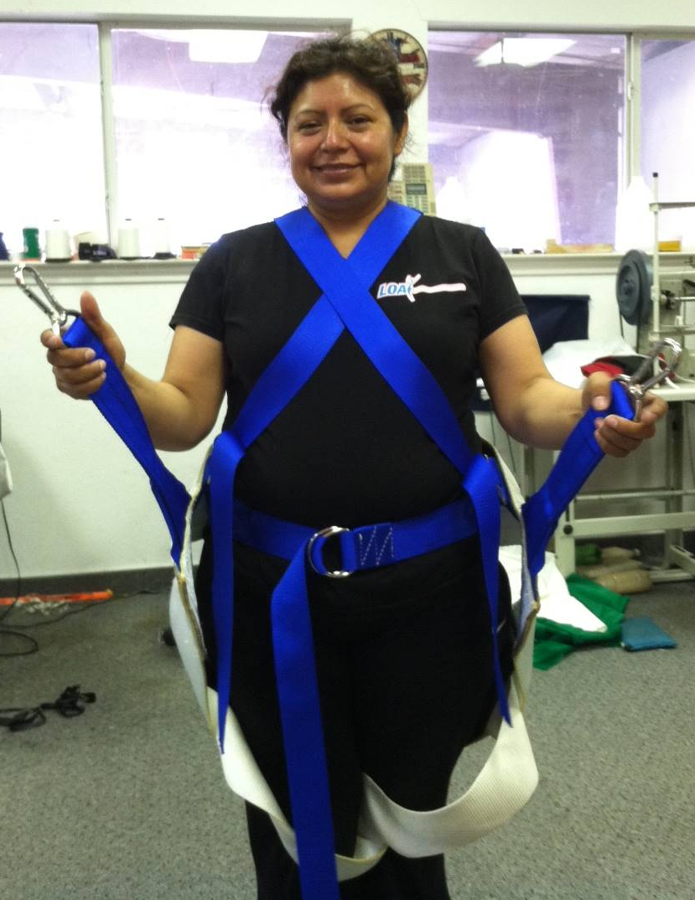

INSTRUCTIONS
1) Lay harness flat on ground with pads facing up
2) Undo belt and lay flat
3) Slip both legs through leg loops and pull up
4) Pull back strap around small of back where a belt would go
5) Cinch belt around waist and pull strap through both “D” rings and loop strap back through the top until snug
6) Connect spring clips to rings on chute person is suspended from and check belt for tightness; make is snug!
7) Put on life jacket over harness. NEVER PUT HARNESS OVER LIFEJACKET!
ALWAYS BE SURE HARNESS IS A PROPER FIT FOR THE SIZE OF PERSON WHO IS WEARING IT. NEVER PUT ON A HARNESS LARGER OR SMALLER THAN NECESSARY. BE SURE ALL CONNECTION POINTS ARE TIGHT AND SECURE.

